Brad Cochrane |  |  |  |  |  | The Story First Speaker
Brad @Cochrane.net
425-802-9818
www.StoryFirstSpeaker
Speaker Agreement
Parties
- Organization:
- Speaker: Brad Cochrane
Event Details
Title
- XX
Date
- XX
Call Time
- XX
Event Time
- XX
Location
- XX
Sponsor
- XX
Type
- Keynote, Seminar, Workshop
Contact
- XX
- XX
Attendee Count
- XX
Room Requirements
- Carafe of hot water and cup (for tea)
- Display table
AV Requirements
- Power, Projector with room audio, Projection Screen
- For a large room, wearable wireless microphone
Notes
- (XX) Story First Marketing books provided
- (XX) The Five Storylines companion workbooks provided

Content Ownership
Brad Cochrane retains ownership of content presented at event. No reuse of material including slides, audio, and/or video recording without express written permission of Brad Cochrane. Brad asks that attendees refrain from photographing slides or other content presented.

Financial
Speaker Fee  Book Purchase  Hotel, Transportation, and Expenses  ½ Payable upon agreement  ½ Payable at event |  | (XX) Minute Keynote, Workshop, or Seminar  XX Story First Marketing Books and XX Build Your Brand Workbooks at $xx per  Estimate of all expenses  Total |  |  |  |  |  |  |  | $XX  $XX  $XX  $XX
Attendee Description
SAMPLE: Small business owners looking to grow their business by reaching customers with a unified brand and communicating their genuine value to customers.

Introduction
SAMPLE: In business, trust in a brand is the coin of the realm. Without a unified brand that is genuine and coherent, the huge investment of money, time, and effort to reach, engage, and move customers to action is wasted. If a business fails to connect, what's the cost of lost opportunity? How does a company quantify business that never was?

But Brand is more than a product or the sum of its features. Brand is ultimately the story that businesses tell their customers and, more importantly, tell themselves. Storytelling is a powerful approach to attract, engage, and move customers to action.

Can companies afford to ignore the power of stories?

Event Description
SAMPLE: Effective businesspeople know that there are Five Storylines they need to tell well in any situation and at any time. Do companies know and embrace their Core Storyline? How about their Action Story, Descriptive Story, Journey Story, and Data Story?

In this entertaining presentation, Knowing Yourself - Developing Your Brand, Your Pitch, attendees will learn and master the Five Storylines that their company needs to align their business, engage employees, and move customers to action. Armed with real world examples, attendees will walk away with tools for effective storytelling.

Customization
SAMPLE: This presentation will be customized for small business owners and the XXXX.

Takeaways
SAMPLE: Attendees will…
- Understand the Five Storylines
- Apply the Five Storylines to their business
- Leave with personal actionable guidelines
- Take home worksheets and messaging pillars
Agreement
Speaker Brad Cochrane  Date: |  |  |  |  |  |  | Organization Representative  Date
Bio
Brad Cochrane

- Keynote Speaker
- Certified Trainer
- Published Author

My personal mission is to champion storytelling and its power to change how people think, feel, and act because we all can make a difference.

With a career in broadcast television, a stint in technology marketing, and expertise as a public speaker, Brad delivers a stimulating, entertaining, and informative experience for your attendees.

Brad weaves in real-world experiences to illustrate and illuminate. Perhaps it’s a personal story of working with Steve Jobs, befriending Carlos Santana or interviewing Al Gore. Attendees take home knowledge, insights, and skills to make a positive impact through storytelling.

Bio Picture


Testimonials
Brad's presentation was a big hit. Attendees were overwhelmingly positive about Brad as an "Engaging Speaker.
-Don Morgan, MarketMix Chair

Your presentation was wonderful and as promised.
-Sherry L. Rollo, Attendee, Licensing Executives Society

Scored in the top 10% of all speakers.
-Yvonne Brandon, American Marketing Association, Puget Sound

Social Media
www.Story1stMarketing.com
www.LinkedIn.com/in/bradcochrane
https://www.youtube.com/channel/UCKRVXzAIcEYU9HI_oBxLyiw

Book Sales and Content
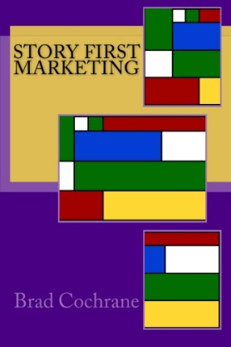 |  | Story First Marketing: Move Your Customers to Action
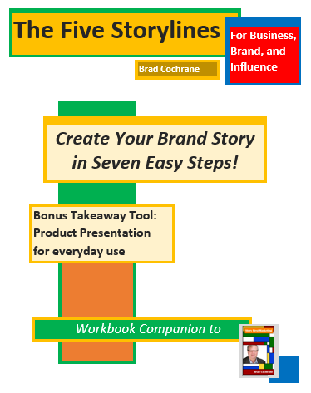 |  | The Five Storylines for Business, Brand, and Influence  Get them  - Amazon  - Speaking Events  Handouts  www.Story1stMarketing.com

